Maruti Pundlik Dalvi
Subject: DSCC Lab
Roll no. MCA2024096
Seat no. 2018274

Q.1 Implement mutual exclusion using Token ring algorithm
TokenRingServer.java
public class TokenRing {

/**
* @param args the command line arguments
*/

public static void main(String[] args) throws Exception {
DatagramSocket ds = new DatagramSocket(2000); // fixed server port
System.out.println("Server listening on port 2000...");

while (true) {
byte[] buffer = new byte[1024];
DatagramPacket dp = new DatagramPacket(buffer, buffer.length);
ds.receive(dp);

String msg = new String(dp.getData(), 0, dp.getLength());
System.out.println("Message from client: " + msg);
}

}

}

Client1:
public class TokenRingCLient1 {
public static void main(String[] args) throws Exception {
// Automatically bind to any available free port
DatagramSocket ds = new DatagramSocket();
BufferedReader br = new BufferedReader(new InputStreamReader(System.in));

boolean hasToken = true; // first client starts with the token
InetAddress localhost = InetAddress.getLocalHost();

// Server port
int serverPort = 2000;

// Next client port (Client 2) - you can hardcode or pass as argument
int nextClientPort = 0; // will be entered by user

System.out.print("Enter next client port to pass token: ");
nextClientPort = Integer.parseInt(br.readLine());

System.out.println("Your local port: " + ds.getLocalPort());

while (true) {
if (hasToken) {
System.out.print("Do you want to enter CS? (yes/no): ");
String choice = br.readLine();

if (choice.equalsIgnoreCase("yes")) {
System.out.print("Enter message: ");
String msg = "Client1 --> " + br.readLine();
DatagramPacket dp = new DatagramPacket(msg.getBytes(), msg.length(), localhost, serverPort);
ds.send(dp);
System.out.println("Message sent to server.");
}

// Pass the token
String token = "Token";
DatagramPacket dpToken = new DatagramPacket(token.getBytes(), token.length(), localhost, nextClientPort);
ds.send(dpToken);
hasToken = false;
System.out.println("Token passed to next client.");
} else {
System.out.println("Waiting for token...");
byte[] buffer = new byte[1024];
DatagramPacket dp = new DatagramPacket(buffer, buffer.length);
ds.receive(dp);

String received = new String(dp.getData(), 0, dp.getLength());
if (received.equals("Token")) {
hasToken = true;
System.out.println("Token received! You can enter CS.");
} else {
System.out.println("Received unknown message: " + received);
}
}
}
}
}

Client2:
public class TokenRingClient2 {
public static void main(String[] args) throws Exception {
DatagramSocket ds = new DatagramSocket(); // automatic free port
BufferedReader br = new BufferedReader(new InputStreamReader(System.in));

boolean hasToken = false; // second client starts without token
InetAddress localhost = InetAddress.getLocalHost();

// Server port
int serverPort = 2000;

// Next client port (Client 1)
int nextClientPort = 0; // will be entered by user
System.out.print("Enter next client port to pass token: ");
nextClientPort = Integer.parseInt(br.readLine());

System.out.println("Your local port: " + ds.getLocalPort());

while (true) {
if (hasToken) {
System.out.print("Do you want to enter CS? (yes/no): ");
String choice = br.readLine();

if (choice.equalsIgnoreCase("yes")) {
System.out.print("Enter message: ");
String msg = "Client2 --> " + br.readLine();
DatagramPacket dp = new DatagramPacket(msg.getBytes(), msg.length(), localhost, serverPort);
ds.send(dp);
System.out.println("Message sent to server.");
}

// Pass the token
String token = "Token";
DatagramPacket dpToken = new DatagramPacket(token.getBytes(), token.length(), localhost, nextClientPort);
ds.send(dpToken);
hasToken = false;
System.out.println("Token passed to next client.");
} else {
System.out.println("Waiting for token...");
byte[] buffer = new byte[1024];
DatagramPacket dp = new DatagramPacket(buffer, buffer.length);
ds.receive(dp);

String received = new String(dp.getData(), 0, dp.getLength());
if (received.equals("Token")) {
hasToken = true;
System.out.println("Token received! You can enter CS.");
} else {
System.out.println("Received unknown message: " + received);
}
}
}
}
}
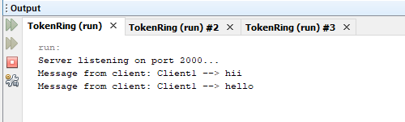

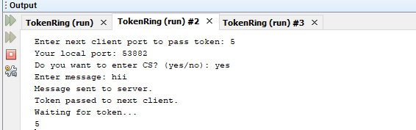

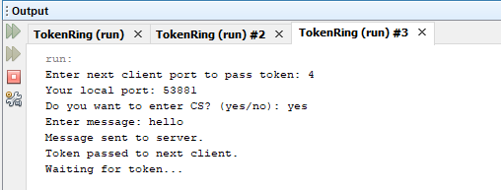

Q.2 Implement a Server to do the following: (use RPC) (Make use of datagram)
- User will enter two distances from the client (in Kilometers and meters) (Eg: 3km 500m and 4Km 800 m)
- Server will add kilometer and meter components separately
- The client side receives the result and display the value
  - only in kilometer (8.3 km)
  - only in meter (8300 m)

Server Program
import java.util.*;
import java.net.*;
import java.io.*;
/**
*
* @author Hiray_Computer Lab
*/
import java.net.DatagramPacket;
import java.net.DatagramSocket;

public class DistanceRPC {
public static void main(String[] args) {
try {
DatagramSocket socket = new DatagramSocket(9999);
System.out.println("UDP Server running on port 9999...");

byte[] receiveBuffer = new byte[1024];

while (true) {
DatagramPacket packet = new DatagramPacket(receiveBuffer, receiveBuffer.length);
socket.receive(packet);

String data = new String(packet.getData(), 0, packet.getLength());
String[] values = data.split(" ");

int km1 = Integer.parseInt(values[0]);
int m1 = Integer.parseInt(values[1]);
int km2 = Integer.parseInt(values[2]);
int m2 = Integer.parseInt(values[3]);

int totalMeters = m1 + m2;
int extraKm = totalMeters / 1000;
int remMeters = totalMeters % 1000;

int totalKm = km1 + km2 + extraKm;

String result = totalKm + " " + remMeters;

byte[] sendBuffer = result.getBytes();
DatagramPacket sendPacket = new DatagramPacket(
sendBuffer, sendBuffer.length,
packet.getAddress(), packet.getPort()
);
socket.send(sendPacket);
}

} catch (Exception e) {
e.printStackTrace();
}
}
}

Client Program:

import java.net.DatagramPacket;
import java.net.DatagramSocket;
import java.net.InetAddress;
import java.util.Scanner;

public class DistanceClient {
public static void main(String[] args) {
try {
DatagramSocket socket = new DatagramSocket();
InetAddress serverAddress = InetAddress.getByName("localhost");
Scanner sc = new Scanner(System.in);

System.out.println("Enter first distance:");
System.out.print("Kilometers: ");
int km1 = sc.nextInt();
System.out.print("Meters: ");
int m1 = sc.nextInt();

System.out.println("\nEnter second distance:");
System.out.print("Kilometers: ");
int km2 = sc.nextInt();
System.out.print("Meters: ");
int m2 = sc.nextInt();

// Prepare message
String message = km1 + " " + m1 + " " + km2 + " " + m2;
byte[] sendBuffer = message.getBytes();

// Send to server
DatagramPacket packet = new DatagramPacket(sendBuffer, sendBuffer.length, serverAddress, 9999);
socket.send(packet);

// Receive result
byte[] receiveBuffer = new byte[1024];
DatagramPacket receivePacket = new DatagramPacket(receiveBuffer, receiveBuffer.length);
socket.receive(receivePacket);

String result = new String(receivePacket.getData(), 0, receivePacket.getLength());
String[] res = result.split(" ");

int totalKm = Integer.parseInt(res[0]);
int remMeters = Integer.parseInt(res[1]);

// Convert for display
double kmValue = totalKm + (remMeters / 1000.0);
int meterValue = (totalKm * 1000) + remMeters;

System.out.println("\n------ RESULT ------");
System.out.println("a) Distance in kilometers: " + kmValue + " km");
System.out.println("b) Distance in meters: " + meterValue + " m");

} catch (Exception e) {
e.printStackTrace();
}
}
}
